**Daily Progress (Siemens R&D Internship)**

07/05/2018

* Completed formalities in early hours and came to R&D building after lunch to study Siemens Manual of all Motion Control related solutions offered by the company. Before we move to going through each of the product offered by the company, let’s understand why it is needed in first place?
* Essentially every industry has to face different challenges in manufacturing and process sections. That’s where Siemens’ solution based on TIA and TIP come into play. The industry software enables to optimize entire value chain while mechanical and electrical components offer technology for entire drive chain. Products are RoHS compliant and certified to DIN making them more environment friendly.
* TIA’s chart in the manual clearly shows how maximum transparency is ensured through less interfacing requirements-from field level, control level, operations level to management level. Thus maximum interoperability and reduced complexity of automation solutions.
* **SIMOTION** and **SINAMICS** together form a platform using which one can adjust the control system to machine requirements. Why should one use Siemens Motion Control?
* High performance servo, linear, torque and standard motors.
* Supports over entire life cycle of machine. Nearly 300 service outlets in more than 100 countries.
* Application Support. To ensure projects are made from an idea to finally an operational machine.
* Technology Partnership with customers so as to make practical and future oriented automation solutions.
* Benchmark in energy efficiency and energy management.

Product Level Planning Level System Level

Optimization

Saving due to a common DC link, buffering and control due to regulated in supply.

Identification

Energy Consumption Display

Evaluation

Calc. of Energy Consumption & energy optimised system solution

Fig 1: Energy Management’s three phases

* **SINAMICS**:-

It is a family of drives made in Siemens for various applications from simple pump (process industry), applied single drives (centrifuge, elevators etc.) to high precision servo drives (turbines) and high dynamic servo drives (packaging and printing operations)

* Each version is based on a platform concept to integrate its all elements. SINAMICS is part of TIA concept to make cost effective solutions based on SIMOTION, SINUMERIK and SIMATIC control systems. Quality management in accordance with DIN EN ISO 9001

|  |  |  |
| --- | --- | --- |
| **Sl No.** | **SINAMICS Variant** | **Application** |
| 1 | SINAMICS G | Standard applications with Asynchronous motors. Less stringent requirements regarding dynamic performance of motor speed. |
| 2 | SINAMICS S | Complex drive tasks with synchronous and asynchronous motors both and fulfils stringent requirements regarding dynamic performance and accuracy as well as integration of extensive technological functions in drive control system |
| 3 | SINAMICS DCM | DC drive addressing both basic and demanding drive applications |

Table 1: SINAMICS Variants

|  |  |  |  |  |  |
| --- | --- | --- | --- | --- | --- |
| **Converter** | **App. Type** | **SINAMICS Variant** | **Control Modes** | **Power** | **Applications in detail** |
| Low voltage AC converters | For Basic Applications | SINAMICS G110 | V/f Control | 0.12..3kW | Pumps, fans, conveyor belts |
| SINAMICS G110D | V/f Control/FCC | 0.75..7.5kW | Conveyor technology |
| For high quality applications | SINAMICS G120 | V/f Control/Vector Control | 0.37..250kW | Pumps, fans, conveyor belts, compressor, mixers, mills. |
| SINAMICS G120D | 0.75..7.5kW |
| SINAMICS G130/G150 | 75..1500kW |
| For basic servo drives | SINAMICS S110 | Servo Control | 0.12..90MW | Single-axis positioning applications for machine and plant engineering |
| For demanding applications | SINAMICS S120 | V/f Control/Vector Control/Servo Control | 0.12..4.5mW | Motion Control applications in production machines(packaging, paper, plastic, metal forming and so much more |
| SINAMICS S150 | 75…1200kW | Test stands, cross cutters, centrifuges |
| DC Converters | For basic and demanding applications | SINAMICS DCM | Closed Loop Control/Torque Control | 6kW…30MW | Rolling mills, cross cutters, wire-drawing machines, kneaders, extruders, lifts, test stand drives |
| Medium Voltage AC Converters | For high power applications | SINAMICS GM150/SM150/GL 150/SL 150 | V/f Control/Vector Control | 0.8…120MW | Pumps, fans, conveyor belts, compressor, mixers, rolling mills, excavators, extruders, test stands |

Table 2: SINAMICS Models and Details

* **S120 in detail:**
* Modes of Control:-

Vector Control is used for drive solutions with continuous material webs like wire-drawing machines, film and paper machines etc. Servo control mode is used for cyclic processes with precise highly dynamic position control and servomotors in textile, packaging, printing machines and machine tools.

* Provides modularity for mechanical engineering (free combination of power a nd control performance) and greater flexibility with central control intelligence.
* Functions for better efficiency like speed control, torque control, positioning functions, intelligent starting functions for independent restart in case of power failure, BICO tech with inter connection of drive related I/Os for easy adaptation of drive system to its operating environment and integrated safety functions.
* DRIVE CLiQ (Digital interface between all components)
* Electronic rating plates integrated in every component so that they are detected automatically via a DRIVE CLiQ link. No need to enter data manually during commissioning thereby making the process quicker and better. It contains parameters of electrical equivalent circuit diagram etc.
* Size offerings- Block size, book size compact, book size and chassis.
* SINAMICS S120 along with CU320 is used for positioning tasks and speed control and S120 with SIMOTION D is used for sophisticated motion control tasks directly in the drive.
* Supported with both PROFIBUS (standard fieldbus of TIA system) and PROFINET (control data to be exchanged at high speed via PROFINET IO with IRT or RT. Also uses standard IT mechanisms TCP/IP to transport information)
* Components of SIMANICS S120 includes line side components (line reactors, line filters, and active interface modules), line modules (basic, smart, and active), power supply, DC link components (braking module, braking resistor, capacitor module, control supply module), control units(CU 310/320-2), control units SIMOTION (D410/25/35/45-1,CX32), motor modules(single & double), supplementary system components, power modules and load side components(motor reactors and sine wave filters)
* To operate asynchronous (1PH8/PH7/PL6) and synchronous (1PH8/ FT7/ FK7/ FN3/ FN6/ FW6/ FW3) motors. Connected by power cables/signal cables.
* Motors- Servo, main and direct drives.
* SIZER configuration tool & CAD creator.
* MOTION CONNECT 500/700/800.
* **SIMOTION in detail:**
* Combines three open loop control functions of Motion Control, PLC and technology functions to reduce engineering overhead, increase machine performance, fast system response and simple transparent programming for simpler debugging.
* Three components:-
  + Engineering system (For programming parametrization, graphical or text based programming and test diagnostics)
  + Runtime system (PLC, positioning, gear, Cam and interpolation)
  + Hardware platforms (Controller based, Drive based and PC based)

Abbreviations: (Learnt Today)

* TIA- Total Integrated Automation
* TIP- Total Integrated Power
* RoHS- Restriction of Hazardous Substances
* ERP- Enterprise Resource Planning
* MES- Manufacturing Execution Systems
* DRIVE-CLiQ- Drive Com­­­­­­­­­ponent Link with IQ

08/05/2018

* SIMOTION Hardware based platforms:
* **SIMOTION D** (Compact and integrated in drive)

Integrated in closed loop control module of SINAMICS S120 drive system. Two versions: single axis (D410) and multi axis (D4x5). Two integrated PROFIBUS interfaces supporting PROFIdrive and two industrial Ethernet interfaces. Optional communication board to connect via PROFINET.

* **SIMOTION C** (Modularity and flexibility)

It’s a motion controller based on SIMATIC S7-300 design. 2 variants available with different interfaces but rest of the specs all the same.

* **SIMOTION P** (Open for lots of tasks)

PC based Motion Control System. Two variants:

* P350-3: Comes with Windows XP Professional for tasks other than high end. It has an excellent processor performance. Designed for applications with exacting performance requirements (such as hydraulic applications with highly dynamic position and pressure control loops). Different panel fronts available and for connection of I/Os there is both PROFIBUS and PROFINET variants.
* P320-3: Designed for Embedded PC based motion control applications. Compact (small footprint making applications in space constraint environment easier) and ideal for applications in harsh environments. Linked to SIMOTION fronts by means of Remote Panel PC kit. Available only as PROFINET variant.
* **SCOUT** is engineering system for SIMOTION: User friendly, programming for everyone, central management with integrated tools, test and diagnostics.
* Communication Systems: Digital field bus systems handle the communication between the controller, the device and executing units. Two types:
* Process communication:
* Data communication:

Bus Cycle breathes. It can be tolerated for simple drive applications or for drives in standalone operation. For high accurate drive applications, it should be ensured that bus cycle is constant irrespective of volume of data communication. To synchronise connected devices to communicate together so that cycle time of bus is nearly constant, we need isochronous mode in which an additional clock signal is used. This operation must be very quick and accurate in case of motion control systems. Acceptable deviations are jitters (< 1μs)

* **PROFIBUS**

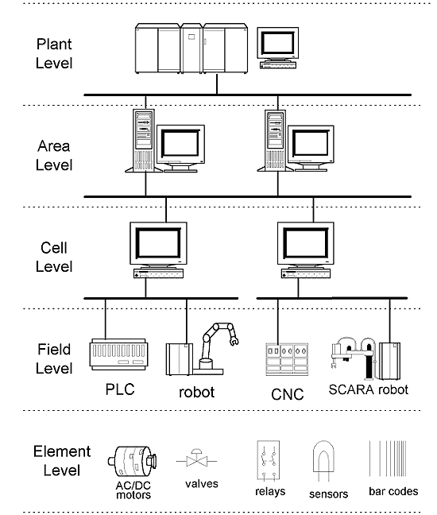

FMS operates on Field level and cell level of industrial communication hierarchy.

PROFIdrive is standardized drive profile for PROFIBUS and PROFINET.

Abbreviations: (Learnt Today)

* MCC- Motion Control Chart
* DCC- Drive Control Chart
* LAD- Ladder Logic
* FBD- Function Block Diagram
* ST- Structured Text
* FMS- Fieldbus Message Specification
* PA- Process Automation
* DP- Distributed Peripherals

09/05/2018

* Variable Speed Drives: The speed of a motor can be controlled by using some type of electronic drive equipment, referred to as variable or adjustable speed drives. Variable speed drives used to control DC motors are called DC drives. Variable speed drives used to control AC motors are called AC drives. The term inverter is also used to describe an AC variable speed drive. The inverter is only one part of an AC drive, however, it is common practice to refer to an AC drive as an inverter.
* Developing A Rotating Magnetic Field: A rotating magnetic field must be developed in the stator of an AC motor in order to produce mechanical rotation of the rotor. Wire is coiled into loops and placed in slots in the motor housing. These loops of wire are referred to as the stator windings. The following drawing illustrates a three-phase stator. Phase windings (A, B, and C) are placed 120° apart. In this example, a second set of three-phase windings is installed. The number of poles is determined by how many times a phase winding appears. In this example, each phase winding appears two times. This is a two-pole stator. If each phase winding appeared four times it would be a four-pole stator.
* NEMA Rotor Characteristics:
* Locked Rotor Torque: Locked rotor torque, also referred to as starting torque, is developed when the rotor is held at rest with rated voltage and frequency applied. This condition occurs each time a motor is started. When rated voltage and frequency are applied to the stator there is a brief amount of time before the rotor turns.
* Locked Rotor Current: Locked rotor current is also referred to as starting current. This is the current taken from the supply line at rated voltage and frequency with the rotor at rest.
* Pull Up Torque: Pull up torque is the torque developed during acceleration from start to the point breakdown torque occurs.
* Breakdown Torque: Breakdown torque is the maximum torque a motor develops at rated voltage and speed without an abrupt loss of speed.
* Full-Load Torque: Full-load torque is the torque developed when the motor is operating with rated voltage, frequency and load.
* Full-Load Current: Full-load current is the current taken from the supply line at rated voltage, frequency and load.
* Selecting a Motor: AC drives often have more capability than the motor. Drives can run at higher frequencies than may be suitable for an application. In addition, drives can run at low speeds. Self-cooled motors may not develop enough air flow for cooling at reduced speeds and full load. Consideration must be given to the motor.
* General operating principle of VFD: The converters in the SINAMICS product range are PWM converters with a voltage-source DC link. At the input side, the converter consists of a rectifier (shown in the schematic sketch as a thyristor rectifier) which is supplied with a constant voltage VLine and a constant frequency fLine from a three-phase supply. The rectifier produces a constant DC voltage VDCLink, i.e. the DC link voltage, which is smoothed by the DC link capacitors. The 2-level IGBT inverter on the output side converts the DC link voltage to a three-phase system with a variable voltage VMotor and variable frequency fMotor. This process operates according to the principle of pulse-width modulation PWM. By varying the voltage and the frequency, it is possible to vary the speed of the connected three-phase motor continuously and virtually without losses.
* Pulse modulation method: The power semiconductors of the IGBT inverter (IGBT =Insulated Gate Bipolar Transistor) are high-speed, electronic switches which connect the converter outputs to the positive or negative pole of the DC link voltage. The duration of the gating signals in the individual inverter phases and the magnitude of the DC link voltage thus clearly determine the output voltage and therefore also the voltage at the connected motor.

10/05/2018

* Difference between different sizes of SINAMICS?

1. **Book size**
   * Multi axis applications
   * Connection for shared voltage-source DCC link
   * Full range of cooling options: Internal air, external air, cold plate, and liquid in some cases
2. **Book size compact**

* For machines with high requirements for compactness of drives.
* All benefits of book size with smaller height and extended overload capacity.
* Same design for cooling.

1. **Block size**

* Single axis applications
* Available only as power modules
* CU310 can be snapped onto them directly.
* Internal air/liquid cooling

1. **Chassis**

* For Higher outputs(approximately 100kW and more)
* Available as Line, Power and Motor modules.
* Internal air cooling and special models for extrusion/marine are liquid cooled.
* CU310 can be integrated in Power Modules.

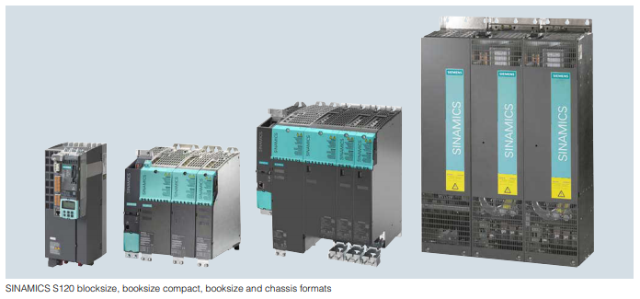

1. **Cabinet**

* For total outputs up to 4.5MW
* Suited for multi motor drives with a central supply infeed and a common DC busbar used in paper-making, roller mills, test stands etc.
* Apart from Motor modules , there are three Basic, Smart and Active line module infeeds are available
* Special braking modules and auxiliary modules
* Comes with degrees of protection IP20, IP21, IP23, IP43 and IP54.
* Communication between Power Modules and central CU takes place via DRIVE-CLiQ
* Line Modules:
* **Basic**: Designed only for infeed operation and not capable of recovering regenerative energy to supply system. Regenerative energy produced is converted into heat by means of a Braking module and a braking resistor. Matching Line reactor must be installed to use as infeed while the line filter is optional.

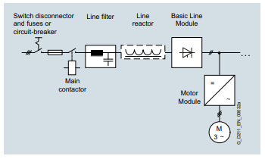

* **Smart**: Supply energy as well as return regenerative energy to supply system. A Braking module and braking resistor required only if drives need to be decelerated in a controlled manner after a power failure. Matching Line reactor must be installed to use as infeed while the line filter is optional.

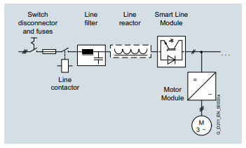

* **Active**: Supply energy as well as return regenerative energy to supply system. A Braking module and braking resistor required only if drives need to be decelerated in a controlled manner after a power failure. Active Line Modules generate a regulated DC voltage which remains constant despite fluctuations in line voltage. They draw a virtually sinusoidal current from the supply which limits any harmful harmonics. Essential to use Active Interface Module.

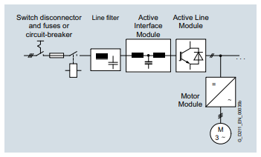

* Methods of cooling:
* Internal Air: Natural cooling/forced ventilation system.
* External Air
* Cold plate
* Liquid
* **Nameplate** Analysis:

1. Volts
2. Hertz
3. Phase: Single/three.
4. Amps
5. Type: Some manufacturers use type to define the motor as single-phase or poly-phase, single-phase or multi-speed or by type of construction. Nevertheless, there are no industry standards for type.
6. Power Factor
7. KW/HP: Mechanical output.
8. RPM: Full loaded Speed.
9. Duty: S1/Cont.
10. AMB: Maximum ambient temperature.
11. Altitude: Above which motor won’t operate at rated data.
12. Enclosure: Degree of protection from environment given by IP/ENCL.
13. Frame: It determines mounting dimensions such as the foot hole mounting pattern and the shaft height. The frame size is often a part of the type designation which can be difficult to interpret because special shaft or mounting configurations are used.
14. NEMA Information:
15. Class INSUL: Farther the letter, better the performance.
16. NEMA Design: Most AC drives use B type.
17. KVA code: Locked rotor current kVA on as per horsepower basis. Farther the letter, more the inrush current per horsepower.
18. Service Factor: Motor can be operated at ‘sf times’ the nameplate power.

* **Derating**: In electronics, derating is the operation of a device at less than its rated maximum capability in order to prolong its life. Typical examples include operation below the maximum power rating, current rating, or voltage rating. Derating curves are drawn by increasing the ambient temperature, altitude etc. beyond there permissible limits to see how the motor’s ratings decrease.
* **Sector specific solutions:**
* *Packaging machines*
* *Printing presses*
* *Textile machines*
* *Converting*
* *Tire production machines*
* *Metal forming technology*
* *Glass production machines*
* *Handling systems*
* *Solar production machines*
* *Ceramics and stone processing machines*
* *Packaging Solutions*:
* Baggers and Wrappers: Automation of tubular bag machines.
* Basics of PLC:

The need of PLC, basics and ladder logic was learnt. And a few examples of material delivery

System etc. were executed.

11/05/2018

* Regenerative AC Drives: Dissipation of regenerative power can be accomplished by returning power to the AC line. The first key to understanding regeneration is to recall the difference between a diode and an IGBT. The diode allows current flow in only one direction, and can’t be turned off. Current flows whenever the diode is forward biased. The IGBT, on the other hand, can pass current in either direction. In the “reverse” direction, it acts simply as an uncontrolled diode. However, it also allows current flow in the “forward” direction, and in that direction the current can be switched on and off. This is what makes the IGBT useful for both regeneration and motor control.
* PLC: The basic elements of a PLC include input modules or points, a central processing unit (CPU), output modules or points, and a programming device. And in some cases a operator interface or HMI is required then it is given accordingly.

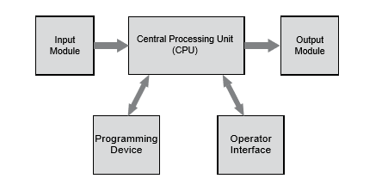

* Before PLCs, hard wired solutions were used. Advantages of using PLC:
* Smaller physical size than hard-wire solutions.
* Easier and faster to make changes.
* PLCs have integrated diagnostics and override functions.
* Diagnostics are centrally available.
* Applications can be immediately documented.
* Applications can be duplicated faster and less expensively

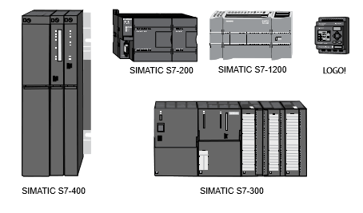

Fig: Types of Siemens PLCs

* Sensors are devices that convert a physical condition into an electrical signal for use by a controller, such as a PLC while actuators are devices that convert an electrical signal from a controller, such as a PLC, into a physical condition.
* Three types of writing a PLC code. Ladder Logic, FBD, and statement list.

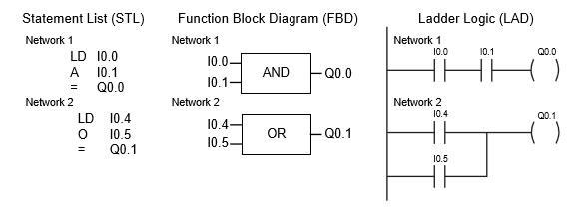

Every program goes through a same repetitive cycle called scan:

* Input contacts ||(NO) |\|(NC) and output coils ( ) and ( · )
* Three types of timers: TON, TOFF, TONR in SIMATIC while in IEC standard, there is TP instead of TONR.

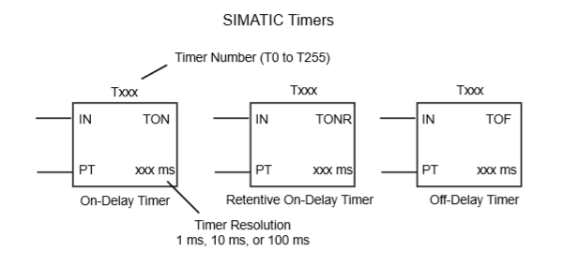

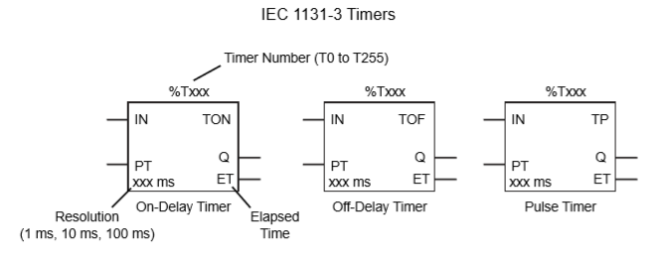

* Three types of counter: Up, Down and Up/Down

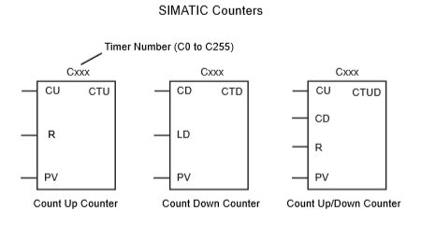

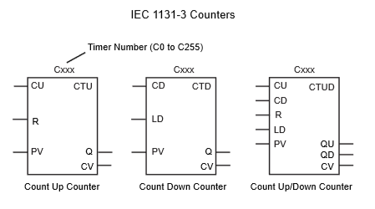

* So far we have covered basics of ladder logic programming and how to write a program in LAD. START/STOP/INTERRUPT/OVERLOAD are some of common input contacts to take care of. Rest of the logic and output coils can vary according to needs of the user. Some of the expansion modules available with S7-200 are:-
* EM241 Modem
* CP 243-1 IT communication processor
* EM277 PROFIBUS DP Module
* CP 243-2 AS-Interface Master module
* EM253 Position Module
* EM231 Temperature Measurement
* SIWAREX MS Weighing Module
* Different types of switches:

